For More Information Contact:
Katherine Gambino
kgambinonyc@gmail.com
845 705 0976

Putnam Chorale Invites for Singers to Join for its Fall Season
Seasoned community choir builds talent for “Songs of Wonder, Mystery & Serenity”

Carmel, NY (August 4, 2025) The Putnam Chorale will begin its 41st season of song on September 8, 2025, with rehearsals at the Carmel High School on Monday evenings. Now with more than 65 singers, the Chorale is seeking new members from Putnam and Dutchess counties to join its ranks of talented performers.

“More singers means a bigger sound, and the ability to tackle more ambitious pieces,” said Dr Jason Tramm, music director and conductor of the Chorale. “The Chorale is a well-established community choir, meaning that the group does not audition singers, except if needed for section placement,” he added. “However, prior experience with singing in a choir or in an educational setting makes learning challenging music easier, so we can better perform a meaningful variety of music.”

In addition to performing masterworks at venues in Putnam and Dutchess counties, many Putnam Chorale singers traveled to Italy in May to perform works by Vivaldi and Mozart in historic churches in Rome, Assisi and Venice. This December, the Putnam Chorale will be performing in two concerts titled: “Shimmering Night: Songs of Wonder, Mystery and Serenity” that will feature music by composers Britten, Gjeilo, and Cohen.

The program will include the following pieces:
Britten: A Ceremony of Carols
Songs of Wonder and Mystery:
Whitacre: Lux Aurumque
Britten: Hymn to the Virgin
Gjeilo: Serenity (O Magnum Mysterium)
Hagenberg: Music of Stillness
Works by Robert Cohen
The Moon
The Serenity of Snow (World Premiere)
Sleep, Baby, Sleep
Gjeilo: Luminous Night of the Soul
Trotta: Veni, Veni Emmanuel

What attracts people to join the Putnam Chorale? “Our singers range in age from 14 to 80; it’s an inviting, down-to-earth mix of people from around the Hudson Valley region. Learning and singing great music is a fun stress reliever as well as a challenging mental and physical exercise,” said Katherine Gambino, Putnam Chorale president. “Anyone who loves to sing should consider joining. We offer rehearsal aids and recordings that make it easier to learn and perform.”

Rehearsals run from 7:00pm to 9:30pm and are held on Mondays at Casey Hall in the main building of the Carmel High School on Fair St. If interested, you may preregister at https://forms.gle/sEmmzDihCPZFWGCE7 or reach out to Contactus@putnamchorale.org for more information. Tuition is $160 per semester.

The Putnam Chorale is a 401(c)3 non-profit organization established in 1984 for the purpose of providing the community with opportunities to perform and to hear great performances.

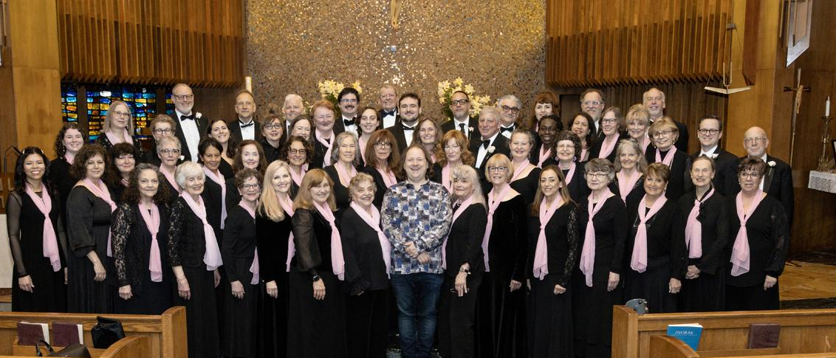
The Putnam Chorale performed the Stabat Mater by Antonin Dvorak at the St. James the Apostle Church and the St. Kateri Church in LaGrangeville in April 2025 to enthusiastic, sold-out audiences.
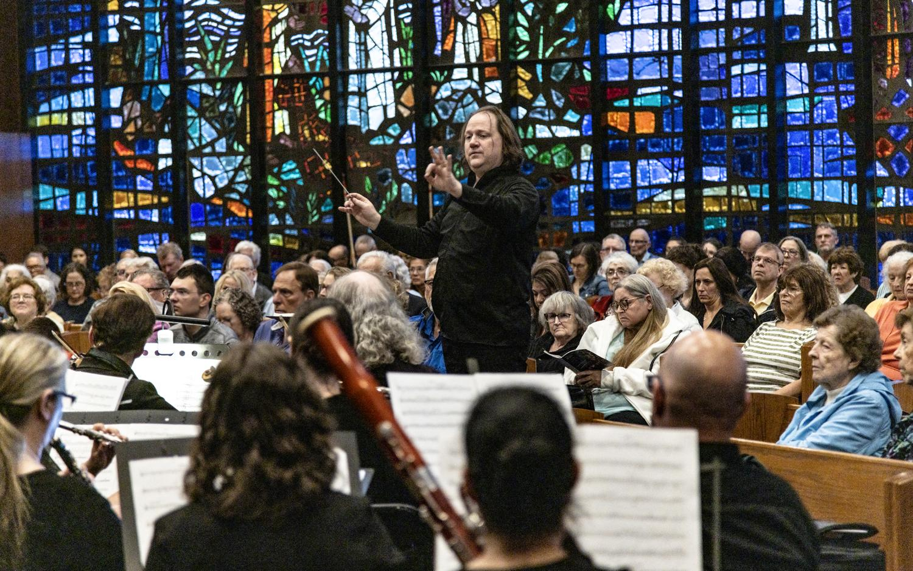

Dr. Jason Tramm conducts the Putnam Chorale, and accompanying professional orchestra during a recent performance.

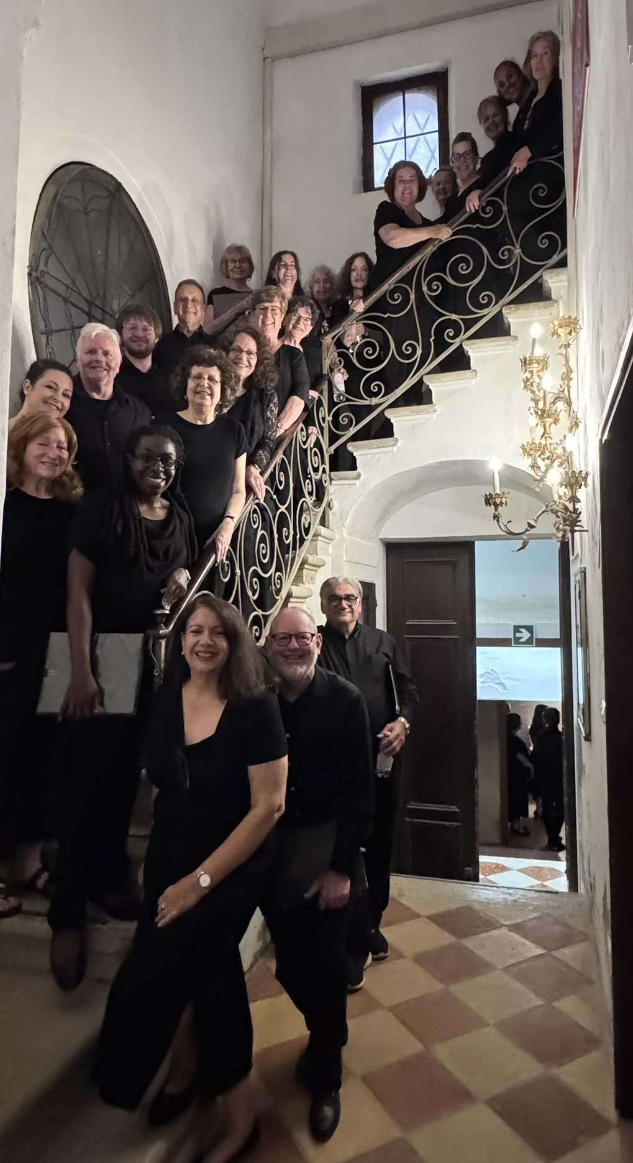

Members of the Putnam Chorale traveled to Italy to perform at historic churches. Here they are pictured at the Chiesa della Pieta in Venice where Vivaldi was music director.

